**ASSIGNMENT ANSWERS**

1Q)**Java**

import java.util.*;

class Main

{

public static void main(String[] args) {

// Create an array with the values (1, 2, 3, 4, 5, 6, 7)

Integer[] arr = {1, 2, 3, 4, 5, 6, 7};

// Shuffle the array

shuffleArray(arr);

// Print the shuffled array

System.out.println(Arrays.toString(arr));

}

public static void shuffleArray(Integer[] arr) {

Random rand = new Random();

for (int i = arr.length - 1; i > 0; i--) {

int j = rand.nextInt(i + 1);

// Swap arr[i] with arr[j]

int temp = arr[i];

arr[i] = arr[j];

arr[j] = temp;

}}

OUTPUT:

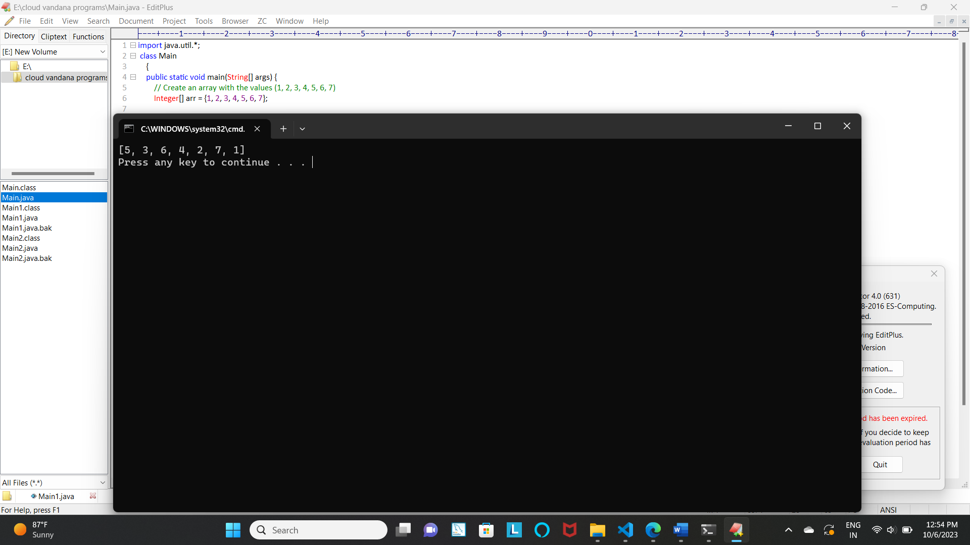

2Q)

import java.util.HashMap;

class Main1

{

public static void main(String[] args) {

String romanNumeral = "X";

int result = romanToInteger(romanNumeral);

System.out.println(result);

}

public static int romanToInteger(String s) {

HashMap<Character, Integer> romanToInt = new HashMap<>();

romanToInt.put('I', 1);

romanToInt.put('V', 5);

romanToInt.put('X', 10);

romanToInt.put('L', 50);

romanToInt.put('C', 100);

romanToInt.put('D', 500);

romanToInt.put('M', 1000);

int result = 0;

int prevValue = 0;

for (int i = s.length() - 1; i >= 0; i--) {

int currValue = romanToInt.get(s.charAt(i));

if (currValue >= prevValue) {

result += currValue;

} else {

result -= currValue;

}

prevValue = currValue;

}

return result;

}

}

OUTPUT:

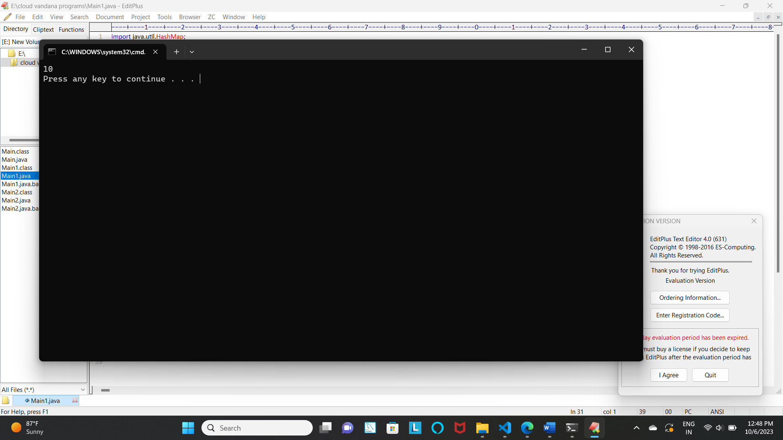

3Q)java

import java.util.*;

class Main2 {

public static void main(String[] args) {

String input = "The quick brown fox jumps over the lazy dog";

boolean isPangram = checkIfPangram(input);

System.out.println(isPangram); // Output: true;

}

public static boolean checkIfPangram(String s) {

// Create a boolean array to mark presence of characters

boolean[] mark = new boolean[26];

// Traverse the string

for (int i = 0; i < s.length(); i++) {

char ch = s.charAt(i);

// If uppercase, convert to lowercase

if (ch >= 'A' && ch <= 'Z') {

ch = (char) (ch + 'a' - 'A');

}

// Mark the current character as present

if (ch >= 'a' && ch <= 'z') {

mark[ch - 'a'] = true;

}

}

// Check if all characters are marked

for (int i = 0; i < 26; i++) {

if (!mark[i]) {

return false;

}

}

return true;

}

}

OUTPUT:

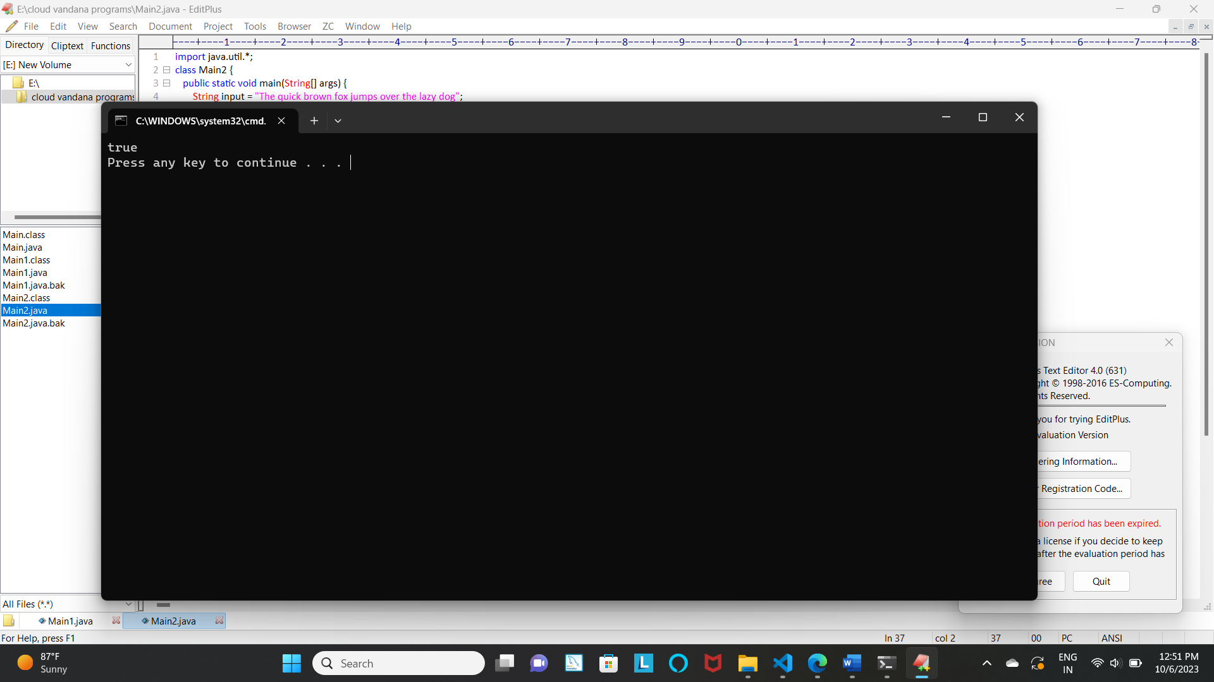

HTML:

4Q)

<!DOCTYPE html>

<html lang="en">

<head>

    <meta charset="UTF-8">

    <meta http-equiv="X-UA-Compatible" content="IE=edge">

    <meta name="viewport" content="width=device-width, initial-scale=1.0">

    <title>SURVEY FORM</title>

    <link rel="stylesheet" href="flesass.css">

    <script>

function Validateform()

{

    var firstname=document.getElementById("firstname").value;

    var lastname=document.getElementById("lastname").value;

    var dob=document.getElementById("dateofbirth").value;

    if(firstname == "" || lastname =="" || dob == ""  )

    {

    alert("Please enter the required fields");

    return false;

    }

    else

    {

        alert("Form Submitted Successfully.");

        return true;

    }

}

        </script>

</head>

<body>

    <section id="Main">

        <div class="bgform">

            <div class="form">

             <h1>SURVEY FORM</h1><center></center>

             <form action="#" onsubmit="Validateform()">

                    <b><label for="First name">First name</label></b>

                    <input id="firstname" type="First name">

                    <b><label for="Last name">Last Name</label></b>

                    <input id="lastname"  type="last name"><br><br>

                    <b><label for="Date of Birth">Date of Birth</label></b>

                    <input type="date" id="dateofbirth" name="birth"><br><br>

                    <b><label for="Country">Country:</label></b>

                    <input id="country" type="country"><br><br>

                    <b><label for="profession">profession</label><b>

                    <input type="text" id="profession" ><br><br>

                    <b><label for="email">Email</label></b>

                    <input type="email" id="email" ><br><br>

                    <b><label for="mobile no">Mobile</label></b>

                    <input type="tel"id="mobile" ><br><br>

                    <b><label for="Gender">Gender:</label></b>

                    <select name="gender">

                        <option value="">please select one</option>

                        <option value="female">female</option>

                        <option value="male">male</option><br>

                    </select><br><br>

                    <button>Submit</button><br><br>

                    <button>resert</button>

                </form>

            </div>

        </section>

</body>

</html>

OUTPUT: 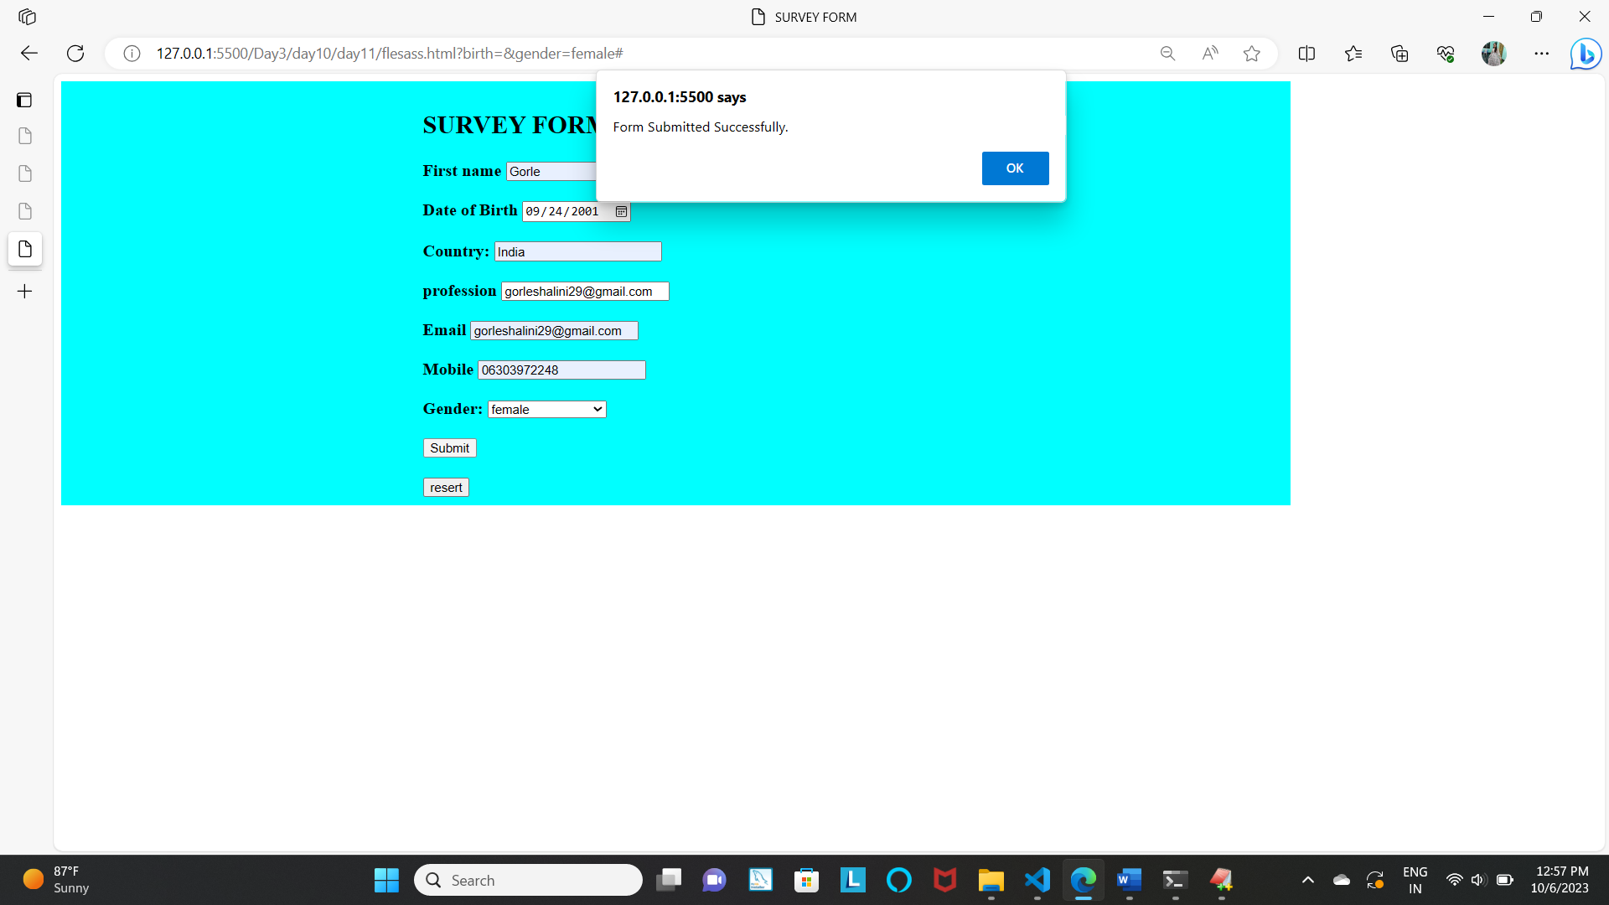

2)OUTPUT:

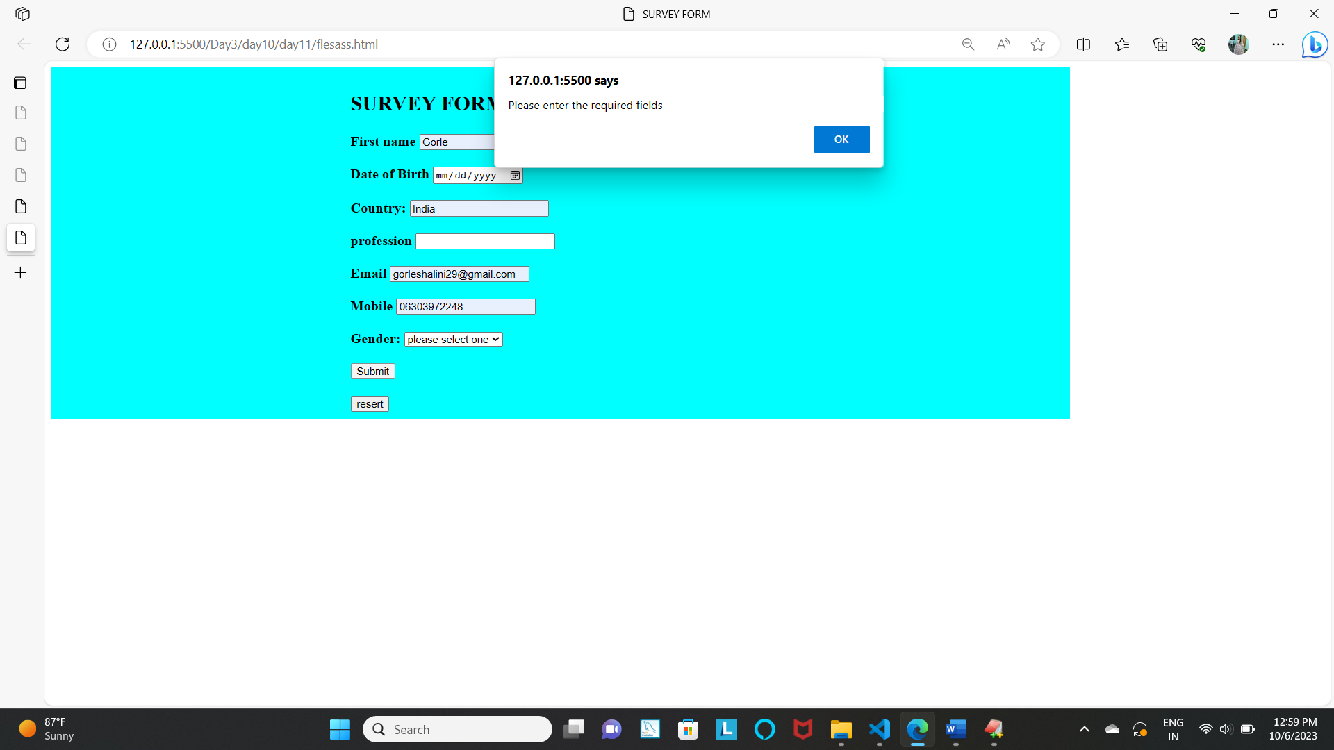

5Q)HTML

<!DOCTYPE html>

<html lang="en">

<head>

    <meta charset="UTF-8">

    <meta name="viewport" content="width=device-width, initial-scale=1.0">

    <title>Basic Calculator</title>

    <link rel="stylesheet" href="styles.css">

</head>

<body>

    <div class="calculator">

        <input type="text" id="result" readonly>

        <div class="buttons">

            <button onclick="addToResult('1')">1</button>

            <button onclick="addToResult('2')">2</button>

            <button onclick="addToResult('3')">3</button>

            <button onclick="addToResult('+')">+</button>

            <button onclick="addToResult('4')">4</button>

            <button onclick="addToResult('5')">5</button>

            <button onclick="addToResult('6')">6</button>

            <button onclick="addToResult('-')">-</button>

            <button onclick="addToResult('7')">7</button>

            <button onclick="addToResult('8')">8</button>

            <button onclick="addToResult('9')">9</button>

            <button onclick="addToResult('')"></button>

            <button onclick="addToResult('0')">0</button>

            <button onclick="clearResult()">C</button>

            <button onclick="calculateResult()">=</button>

            <button onclick="addToResult('/')">/</button>

        </div>

    </div>

    <script src="script.js"></script>

</body>

</html>

OUTPUT:

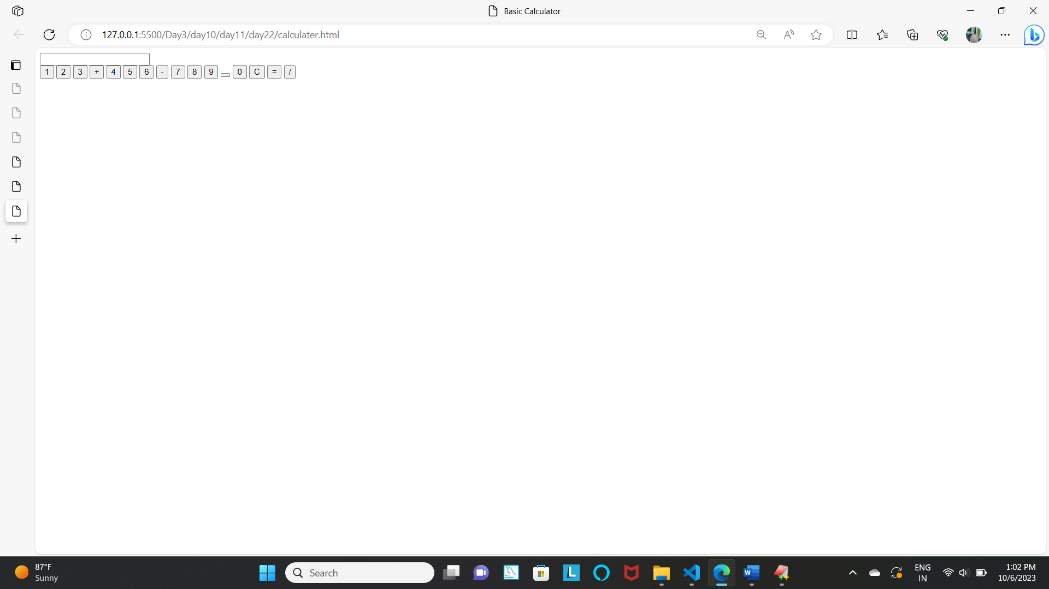

6Q)import java.util.Scanner;

class Reverse

{

public static void main(String[] args)

{

System.out.println("enter the word");

Scanner sc= new Scanner(System.in);

String str=sc.nextLine();

sc.close();

String words[] = str.split(" ");

String reversedStr="";

int i,j;

for (i=0;i<words.length;i++)

{

StringBuffer sb=new StringBuffer(words[i]);

reversedStr+=sb.reverse().toString();

reversedStr+=" ";

}

System.out.println("reversed string:" +reversedStr);

}

}

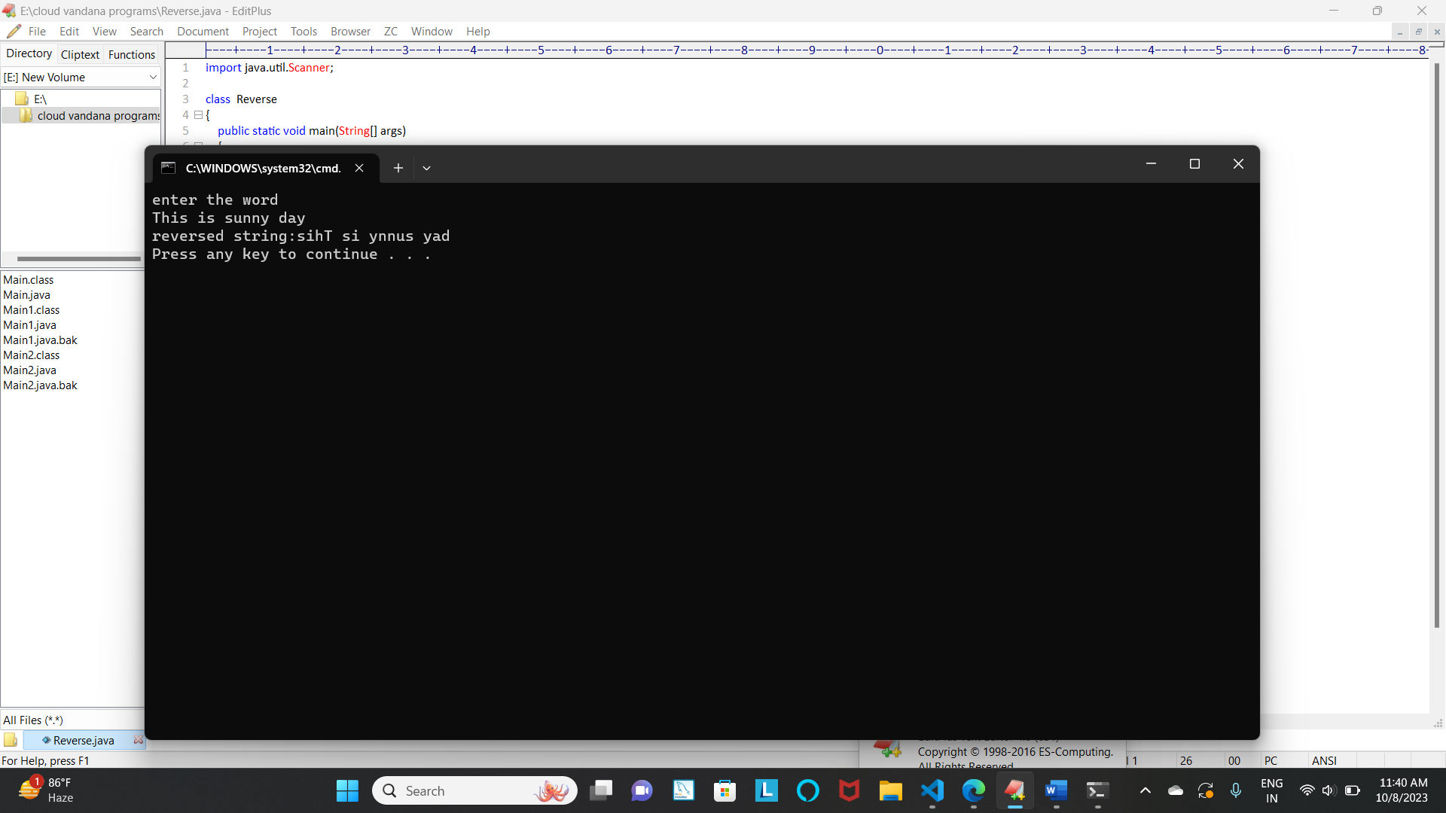

7Q) import java.util.*;

class Array

{

public static void main(String[] args)

{

Integer array[ ]={8,5,6,3,2,1};

Arrays.sort(array,Collections.reverseOrder());

System.out.println(Arrays.toString(array));

}

}

OUTPUT:

